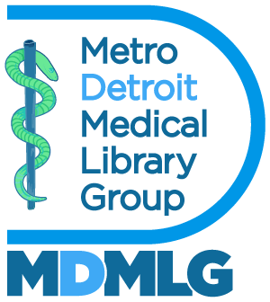

Executive Board Meeting June 25, 2025

**Annual Report 2024 - 2025**

Outreach – Social Media Manager

**Goals and Objectives**

1. To bring awareness of medical librarianship particularly to student members.
2. To showcase events, professional development opportunities, celebrations etc. happening within the MDMLG community.
3. To speak to the benefits of joining MDMLG.

**Accomplishments**

Over the past year,­­ Jillian and I have reached out to students from Wayne State University and the University of Michigan as well as through SIS student groups to generate interest and student membership.

**Metrics**

Our Instagram account: @*DetroitMedicalLibraryGroup* has 52 followers and 238 posts. Our facebook group now has 20 followers and 125+ posts.

Respectfully submitted,

Michelle Rau

Social Media Manager